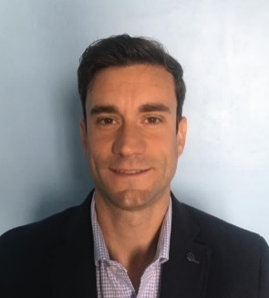

PABLO CABRAL

Sr. Account executive

WORK EXPERIENCE

SKILLS

Nourish an honest, clear communication style.
- Strong Team work
- Confidence - maintaining a positive attitude.
- Motivate others with example.
- Resilience - communicating with conviction.
- Active listening - understanding the customers' needs.
- Use psychology to engage the buyer.
- Establish trust with the buyer.
- Self confident.

REFERENCES

Jorge Villar
Buenos Aires printing CEO
Buenos Aires printing srl
phone: +54 9 11 5307-8834
jvillar@veryjet.com | www.veryjet.com

PERSONAL DETAILS

DNI: 32669675 / Date of birth: 11/06/86
Civil status: Single / Passport: AAF299859
USA VISA: B1/B2 / Driver license: B1
Address: Flat D / First Floor / 4122 Olleros Street, Buenos Aires
Mobile phone: +541121775791
E-Mail: pablocabral86@hotmail.com

Buenos Aires Printing SRL - Account executive Sr - Dic 19 - Until present
Generate $30 millions in sales for the company, $2 millions per month, conduct cold calling, and execute lead generation activities. Deliver sales presentations and product demonstrations to prospects and recommend customers.
Coordinate cross-functionally with sales and product marketing teams to drive promotional campaigns and execute marketing events
Utilize Salesforce CRM to conduct sales reporting and maintain prospect database.Two employees in charge
Tecnogo Sistemas SRL - Account executive Sr. - Feb 16 - Dic 19
Studying and examining the business trends and global business conditions of the establishment as per the rules and policies of the import administration. Developing business strategies for the development of the organization and implementing tasks in order to yield correct and exact data on time as and when required. Negotiate with national and international suppliers. Attorney in fact. Ten employees in charge
Lenovo - Certification Specialist - Sep 15 - Feb 16 Coordinate electrical certification in Lenovo Argentina. Work with the foreing trade department, laboratories, certification institutions and Government to certified power supplies, computers and servers of Lenovo brand.
Siqat - Certification Specialist July 14 - Feb 16
Coordinate electrical certification in Argentina. Working with the first technologies brands and Institutions.
NCR Corporation - Help Desk April 13 - July 14
Bilingual Hardware support SABRE System. Caribe and Latin America area.

EDUCATION
International Business - not finishes
PE Teacher - 2010
Electronic Technician - 2005
IDIOMS
Spanish = mother tongue
English = bilingual
Portugues = biginne

