PRACTICAL TASK 1

What is marketing?
Marketing refers to the process of promoting and selling products, services, or ideas to a target audience. It involves understanding consumer needs, creating value, and communicating that value to potential customers. Effective marketing helps businesses build brand awareness, drive sales, and ultimately, achieve their goals.

Companies which do marketing

- Digitizal: It is one of Pakistan's top companies for online marketing and development.

- Artimization: It is a marketing company which offers a range of customized solutions to startups e-commerce stores.

- Creative Thumb: It is a digital marketing agency in Pakistan, that offers services such as SEO, PPC.

- Adaxiom tech: It is a leading marketing company provides best solution for SEO, App & Web Development.

Current ad spending
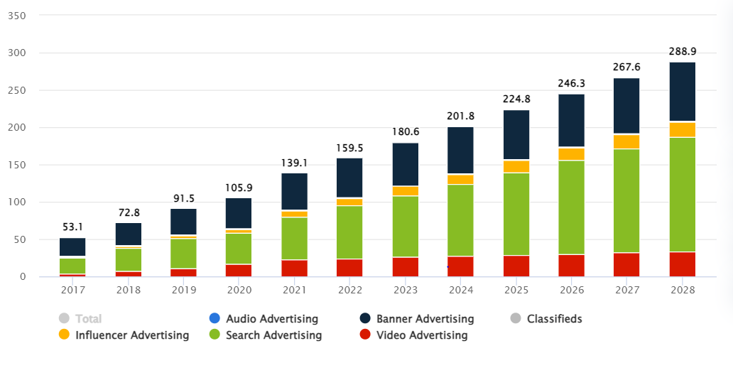

Companies which do Digital Marketing

- Boundless Technologies
- Bitlinks Tech
- Navicosoft
- Graphiters Studio

Companies which do influencer marketing and the name of that influencer marketer

Company | Influencer Marketer
Daraz | Ducky Bhai
Binomo | Vampire YT
PUBG | Star Anonymous

Product Line Companies

- Gul Ahmed
- Sana Safinaz
- Zellbury

Product Length Companies

- HBL (Habib Bank Limited)
- MCB (Muslim Commercial Bank)
- UBL (United Bank Limited)
- Standard Chartered Pakistan
- JS Bank

Product Line Length Companies

- Lux
- Lifebuoy
- Fair & Lovely
- Ponds
- Vaseline

Product mix companies

- Cola-Cola
- Nestle
- Apple

How will you do marketing and allocate its budget

Define Marketing Objectives: Identify specific goals, such as increasing brand awareness, generating leads, or driving sales.

2. Segment Target Audience: Divide your audience into categories based on demographics, behavior, or preferences.

3. Choose Marketing Channels: Select channels that best reach your target audience, such as: - Digital Marketing (Social Media, Email, Search Engine Optimization (SEO), Pay-Per-Click (PPC) Advertising) - Traditional Marketing (Print, TV, Radio, Outdoor Advertising) - Event Marketing (Trade Shows, Conferences, Webinars) - Content Marketing (Blogs, Videos, Podcasts)

4. Allocate Budget: - Digital Marketing: 30-40% (flexible and measurable) - Traditional Marketing: 20-30% (brand awareness and reach) - Event Marketing: 10-20% (targeted and engaging) - Content Marketing: 10-20% (educational and lead generation)

5. Set Metrics and Track Performance: Monitor key performance indicators (KPIs) like website traffic, social media engagement, lead generation, and conversion rates to adjust the marketing strategy and budget allocation.

6. Budget Breakdown: - Campaign Development: 20-30% - Media Buying and Advertising: 30-40% - Event Production and Logistics: 10-20% - Content Creation and Distribution: 10-20% - Measurement and Evaluation: 5-10% Remember, this is a general framework. The actual allocation and budgeting will depend on your specific marketing goals, target audience, and industry.

Suppose you are a brand manager and you want to make that plan successful

As a brand manager, my goal is to make the marketing plan successful by effectively allocating resources and executing the strategy. Here's a more detailed plan to ensure success: Marketing Objectives: 1. Increase brand awareness by 25% among the target audience 2. Generate 500 new leads per quarter through the website 3. Boost sales by 15% within the next 6 months Target Audience: - Demographics: 25-45 years old - Interests: Health and wellness, fitness, and nutrition - Behaviors: Active on social media, frequent online shoppers Marketing Strategies: 1. Digital Marketing: - Social Media: Share engaging content, influencer partnerships, and targeted ads (30% of budget) - Email Marketing: Newsletters, promotional emails, and abandoned cart reminders (20% of budget) - SEO and Content Marketing: Blog posts, videos, and guides to establish thought leadership (20% of budget) - PPC Advertising: Targeted search ads to drive website traffic (30% of budget) 2. Event Marketing: - Sponsor fitness events and conferences to showcase products and build brand awareness (20% of budget) 3. Content Marketing: - Develop a mobile app for workout tracking and nutrition planning (30% of budget) - Partner with influencers and bloggers for product reviews and testimonials (20% of budget) Budget Allocation: - Digital Marketing: 60% (flexible and measurable) - Event Marketing: 20% (targeted and engaging) - Content Marketing: 20% (educational and lead generation) Performance Metrics: 1. Website traffic and engagement metrics (e.g., page views, bounce rate, time on site) 2. Social media metrics (e.g., followers, engagement rate, reach) 3. Lead generation and conversion metrics (e.g., form submissions, sales) 4. Customer satisfaction and retention metrics (e.g., customer surveys, repeat business) Timeline: - Month 1-3: Set up digital marketing campaigns, launch influencer partnerships, and develop content - Month 4-6: Optimize and refine digital marketing campaigns based on performance data - Month 7-9: Execute event marketing activations and launch mobile app - Month 10-12: Analyze results, plan for future activations, and allocate budget for next quarter By following this plan, we'll effectively allocate resources, execute a well-rounded marketing strategy, and measure performance to ensure success.

Product Base Companies in Pakistan

- Systems Limited
- ZAPTA Technologies
- API Pilot

Service Base Companies in Pakistan

- NetSol Technologies
- Techverx
- Xeven Solutions

