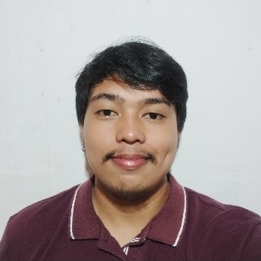
Albert Ragot Jr.
Tierra Verde Sasa, Davao City Philippines #8000
09381490111
albert.ragot06@gmail.com
linkedin.com/in/albert-ragot/

Objective:
Passionate and dedicated WordPress developer with expertise in Elementor, HTML, CSS, JavaScript, React, and web design. Seeking to leverage my technical skills and customer service background to create dynamic and responsive websites, helping businesses establish a strong online presence and achieve their growth goals.

Skills:
- WordPress Development
- Elementor Page Builder
- Convert Figma Designs to Full Function WordPress Site
- Basic Seo Techniques
- Google Business Optimization
- HTML, CSS, JavaScript
- Web Design & Responsive Web Design
- Technical Troubleshooting & Problem-Solving
- Strong Communication & Interpersonal Skills
- Attention to Detail & Accuracy

Professional Experience:
Customer Support Representative / Records Retrieval
OP360 – Morgan & Morgan
July 2023 – June 2024

- Provide exceptional customer support and handle inquiries via phone, email, and chat channels for a leading records retrieval company.
- Efficiently manage and retrieve medical records for legal and healthcare clients, ensuring accuracy and compliance with regulatory requirements.
- Collaborate with internal teams to resolve customer issues promptly and maintain high levels of client satisfaction.

Technical Support Representative
Teleperformance – Xfinity
July 2021 - April 2023

- Delivered technical support and troubleshooting assistance to Xfinity customers via phone and online chat platforms.
- Diagnosed and resolved issues related to internet connectivity, cable TV, and home phone systems, ensuring timely resolution and customer satisfaction.
- Utilized effective communication and problem-solving skills to address customer concerns and provide personalized solutions.

Education:
3rd Year Undergraduate Studies in Information Technology
University Of Mindanao, Matina Davao City
Dates Attended: 2018 – 2020

Portfolio:
For examples of my work, please these websites:
Shine Masters
Classic Americana
Skyline Builders
Apex Constructions

